Credit Name:CSE 2140 2nd Language Programming
Assignment Name: Grade.java
The following questions can help you in thinking critically about your problem-solving processes:
Understanding the Problem
How did you approach understanding the challenge? I understood the challenge by finding that the program need to take a percentage grade and converting it to a letter grade.
Were there any parts of the problem you found confusing at first? If so, how did you resolve that confusion?
The only confusing part at first was when I had to make sure the grade ranges didn't overlap. I didn't have two outcomes for one percentage grade.
Planning the Solution
Did you create a plan or break the problem into smaller steps before coding?
I broke the task into smaller steps. Getting the input, finding the grade and printing the corresponding letter grade.
How did you decide on the tools, data structures, or algorithms to use?
I chose Scanner for input and if-else statements for finding which letter grade corresponds with the percentage because they are the simplest tools for this problem.
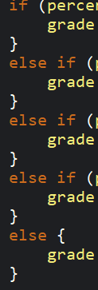

Implementation
Did you write the code in small pieces or attempt the entire solution at once?
I wrote the code in smaller sections, I first did the input, then added how the grades would work and then the output.
How did you test your solution along the way to make sure it was working?
I tested the program by entering different percentages to make sure that each grade worked and I had the right ranges.
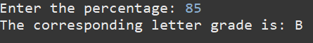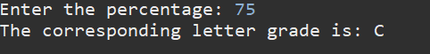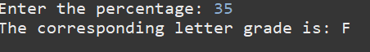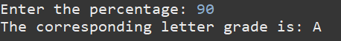

Overcoming Challenges
What part of the problem was the most difficult for you?
The most difficult part was making sure the grades were all accurate and didn’t overlap. I made sure that I wrote the grades in order starting from 90% down, so it wouldn’t be confusing for me and it makes the code look clean and more organized.
.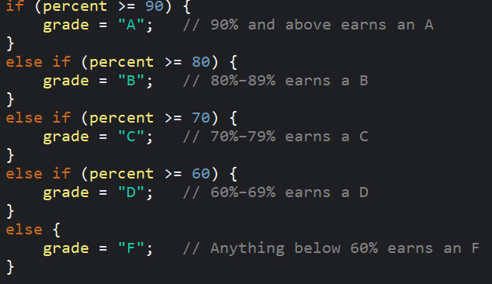
How did you handle moments when you felt stuck or unsure of what to do next?
When I felt stuck I looked back at each range and tested with more percentage grades, if something was wrong I would change the else if statements.
Learning
Was there anything you learned that you think will help you with future challenges?
I learned that organizing code into clear steps is the best as it is much easier to understand the code and find problems.

